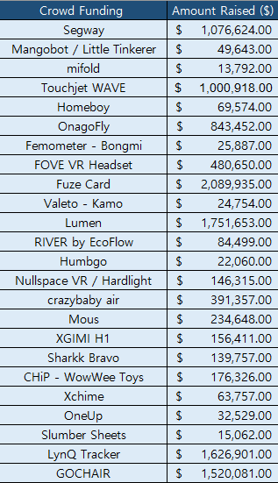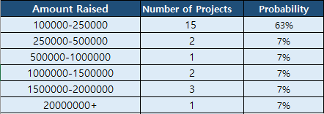

To better approximate the uncertain values in the objective function, we use the Monte Carlo Simulation. From the past data shown on table, we divide the amount raised into groups and assume that each group has a probability of occurring (This is shown in table 2). Note that except for the first range of amount raised, other range have similar numbers. Since we do not have that much data, it seems logical to assume that other range occur with the same probability. We make a simplifying assumption that a crowdfunding project will raise $100,000 with a probability of 63%, $250,000 with a probability of 7%, $500,000 with a probability of 7% and so on. After 5000 simulations, we get an average result of $459,480.



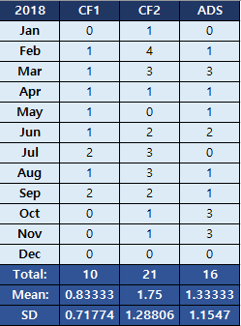

(CF1: Crowdfunding Project1, CF2: Crowdfunding Project2, ADS: Ads only Project)

We check the validity of our simulation by simulating RainFactory’s 2018 revenue. In our revenue simulation, we make a simplifying assumption where the probability of acquiring a CF 1 client is 3%, CF 2 client is 6.6% and Ads Only client is 5% every day. This was calculated by letting the expected value to be equal to the actual number of clients during 2018. The actual annual revenue for the Rainfactory during 2018 was $ 2,150,688. We were able to simulate its revenue within the standard deviation which was $ 2,516,448 with standard deviation being $ 436,056. We infer that the number is higher than the actual value because of lack of data in amount raised by crowdfunding projects. Thus, an amount in the higher price range probably has lower probability of occurring. With this information, we lower the probability of higher price range, as shown in the table.

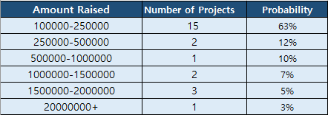

With the new probabilities, we have better approximation of this year’s revenue, which is $2,251,193 with standard deviation being 230669.5.

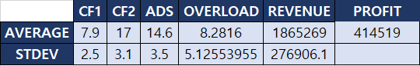

To maximize the annual revenue, the company needs to reduce overload. If we incorporate the labor constraints to our simulator, we get that there will be on average of 8 overloads.



To minimize the overload, we want to come up with a strategy on hiring the right type of person. Using the simulator, we generate average available number of workers at all times. Using this information, change the worker inputs on our simulator and run it again. In this case, since developer and copywriter seem to be the busiest, we tried simulating company revenue after hiring 1 developer and 1 copywriter. Annual cost of hiring both of them sums adds to $81,600; however, by taking this action, with the rate of clients they had during 2018, this would ultimately increase their annual revenue to $2,128,750 and profit to $596,440 and gives a more balances workload for each people.



